Load the file "tcp-1.pcapng" in Wireshark and answer the following questions.
The trace file was captured while uploading ‘1600.txt’ file from a computer (10.63.7.192) to gaia.cs.umass.edu web server (128.119.245.12) using the HTTP POST method.

What is the sequence number of the TCP SYN segment that is used to initiate the TCP connection 2 between the client computer and gaia.cs.umass.edu web server?
0

What are the sequence number and acknowledgement number of the first SYNACK packet sent 2 from the server to the client? How were the values determined by the server? [Note: relative seq and ack values displayed by Wireshark are sufficient, actual values are not required.]
0, 1

What are the minimum and maximum amount of available buffer spaces advertised at the receiver for the entire trace? [screenshot]
29200, 843392

Are there any retransmitted segments in the trace file? Clearly explain why you said yes or no. 2 [screenshot]
There is a packet with the same SEQ # but an incremented ACK #.

What is the throughput (bytes transferred per unit time) of the TCP connection? Explain how you calculated this value. [screenshot]
599394 / 0.636842 = 941197.346

Load the file "udp-1.pcapng" in Wireshark and answer the following questions.

Find a UDP packet in the trace file and describe the name and length (in bytes) of each of the UDP header fields.
Source Port: Indicates the sending port (2 bytes)
Destination Port: Indicates the receiving port (2 bytes)
Length: Specifies the length of the UDP header and payload in bytes (2 bytes)
Checksum: Used for error-checking of the header and data (2 bytes)

Using the statistics feature of Wireshark, determine the percentage of IPv4 UDP packets in the trace.
98.5%

Select a UDP packet in the trace file and expand the “User Datagram Protocol” header. What does the value of the “Length” field represent? (You may consult the textbook for this answer). Verify your claim by showing the relevant details of your selected UDP packet. [screenshot]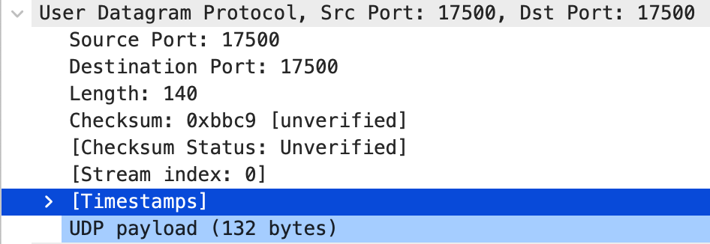

LENGTH: This field represents the total length of the UDP header and the UDP payload in bytes. The UDP header is always 8 bytes long, so to find the length of the payload, subtract 8 from the total length.

What are the source port and the length of the first UDP packet in the trace file? What is the largest possible source port number? [screenshot]
17500, 140, 65535

What is the protocol number for UDP? Give your answer in both hexadecimal and decimal notations along with a screenshot of Wireshark showing those values. [screenshot]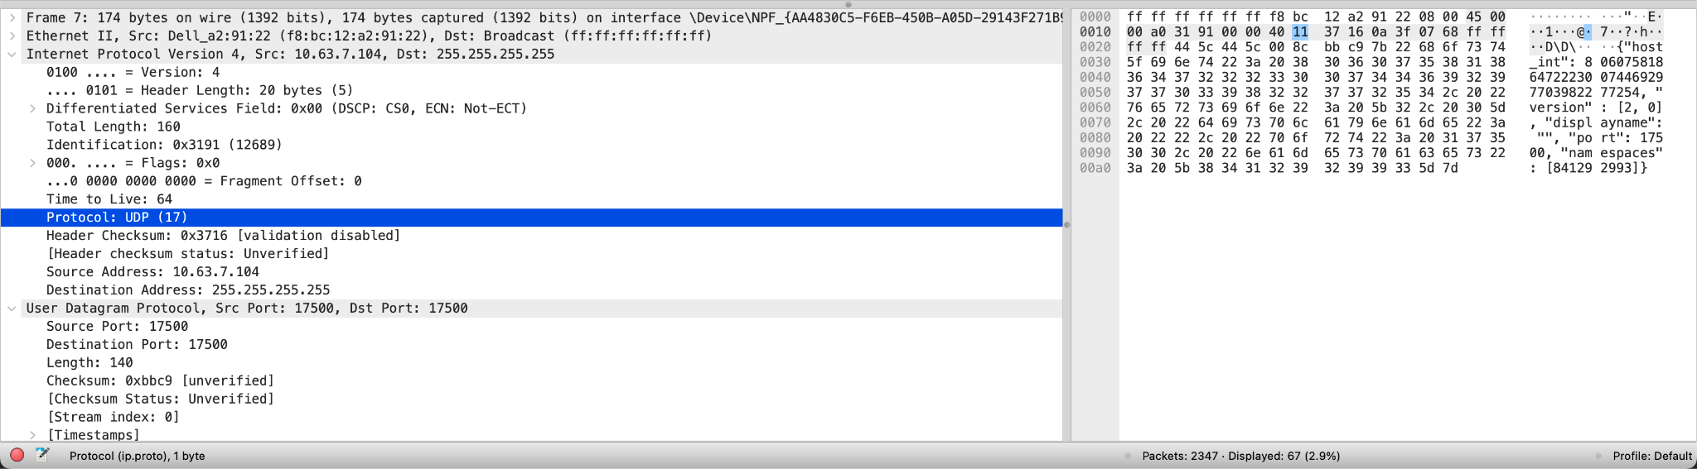
17, 0x11

Load the file "ip-1.pcapng" in Wireshark and answer the following questions.
The trace was generated while executing three traceroute commands with three different UDP datagram sizes (56, 2000, and 3000 bytes) on a computer with an IP address of 10.63.7.60. The IP address of the target host was 103.74.84.13.

Select any of the ICMP echo packets from the trace. Within the IPv4 packet header, what is the value of the upper layer protocol field?
1

What are the values in the “Identification” and the “TTL” fields of the first ICMP packet (ping reply) received by 10.63.7.60?
0xd5d0, 254

Select any of the UDP packets generated from the second traceroute command. How many bytes are in the IP header? How many bytes are in the payload of the IP datagram? Explain how you determined the number of payload bytes. [screenshot]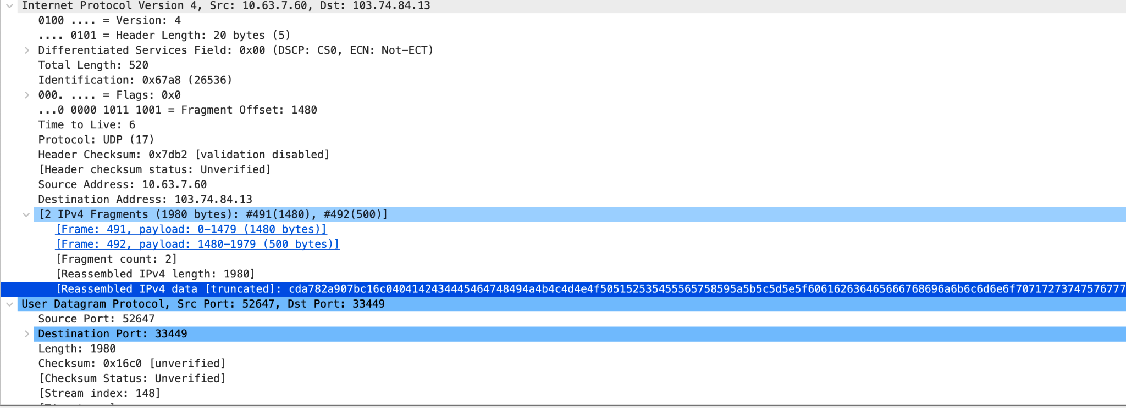
20, 1980, there are 2000 total in the datagram, minus 20 is 1980.

Observe the UDP packets generated from the first traceroute command. Which fields in the IP datagram always change from one datagram to the next within this series of messages sent by 10.63.7.60? [screenshot]
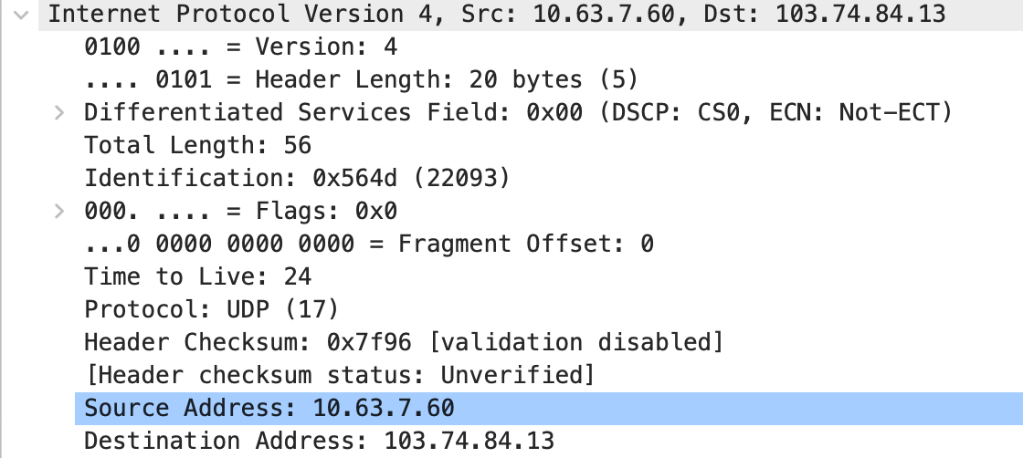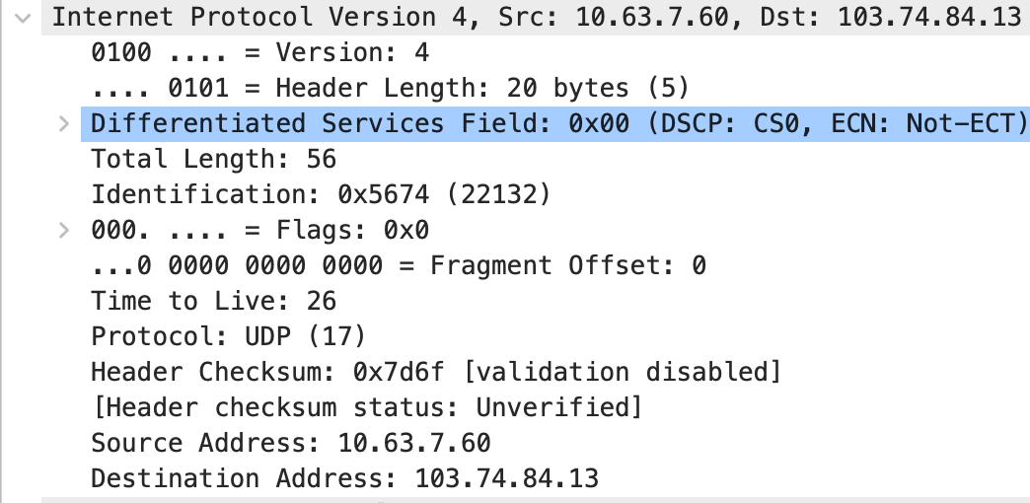
Identification and Header Checksum

Do the values of the “Identification” and the “TTL” fields remain unchanged for all of the ICMP TTL-exceeded replies sent to your computer (IP 10.63.7.60) by the nearest (first hop) router? Why or why not? [screenshot]
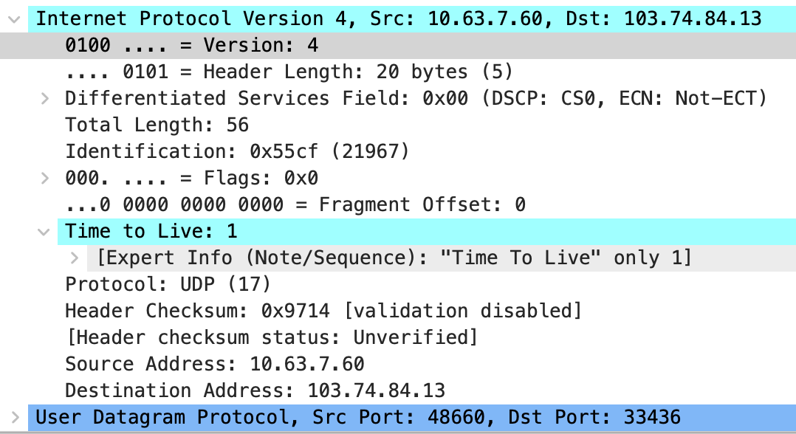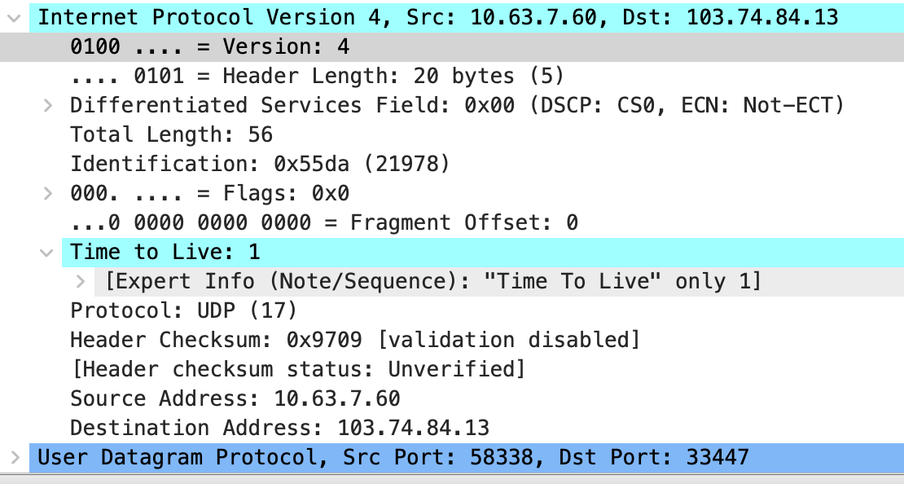
No, they change because each Identification is unique. The TTL stays the same because the hop to the first router is always the same

